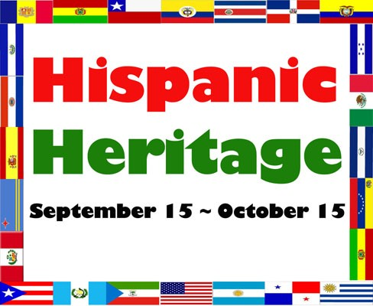
Ms. Roberts’ 1st Grade Newsletter ~ September 2016

Dates to Remember:

Sep. 5 Labor Day Holiday – School closed
Sep 15-Oct 15 Hispanic Heritage Month (Stay tuned for activities & events.)
Sep. 23 ½ Day for students/Teacher PD (Student dismissal at 11:30am)
Coming soon…
Oct 3-7 Fall Break (No School)
Oct. 26 ½ Day for students/Teacher PD (Student dismissal at 11:30am)

What we’re learning:

Reading:
character, setting, events in a fiction story, and main topic and important details in nonfiction text
Grammar/Language:
Sentences, single syllable words, beginning, middle, & ending sounds, number words, and sight words
Math:
Numbers 1-120, addition to 10, place value: tens & ones, count by 10s and 5s
Science/Social Studies:
Energy: electric, light, & sound, Grandparent’s Day, Hispanic Heritage, Fall, Johnny Appleseed

Spelling Words: (students need to be able to read and spell these words)
(8/29-9/2) eleven, twelve, thirteen, fourteen, fifteen, sixteen, seventeen, eighteen, nineteen
(9/6-9/9) fish, with, shop, ship, then, rush, trash, shut, shell, thin
(9/12-9/16) crust, must, trust, lump, bump, just, dusk, jump,dust, hunt
(9/19-9/23 face, safe, cage, name, made, make, cake, age, take, late
(9/26-9/30) like, time, dime, kite, ride,white, hide, smile, bike, ice

Sight Words: (students need to be able to read and write these words fluently)
(8/29-9/2) the, of, and, a, to, in, is, you, that, it, he, was, for, on, are
(9/6-9/9) as, with, his, they, I, at, be, this, have, from, or, one, had, by, words
(9/12-9/16) but, not, what, all, were, we, when, your, can, said
(9/19-9/23) there, use, an, each, which, she, do, how, their, if
(9/26-9/30) review of above 50 sight words – These words must be mastered

Vocabulary Words: (students need to be able to read and use these words)
(8/29-9/2) healthy, rotten, glanced, row, president, dentist, relax, gentle
(9/6-9/9) reach, tangled, polite, appear, disappear, stared, proud, decision
(9/12-9/16) bay, round, slides, goal, note, flippers, follows, tent
(9/19-9/23) autumn, months, winter, gusts, spring, melts, summer, shade
(9/26-9/30) warm, comfort, peaceful, cares, muddy, check, miserable, fluffy
News/Reminders:
My email:dunia.roberts@hsv-k12.org
School Phone: (256)428-7280
M-F 10:00-10:30am, T & Wed 2:45-3:15pm
Our class has lunch at 11:15-11:45 daily.

